LOWER VALLEY FIRE PROTECTION DISTRICT
P.O. Box 520 - 168 North Mesa Street
Fruita, CO 81521-0520
Telephone: (970) 858-3133

***** Retain pages 1 and 2 for your reference*****

The Lower Valley Fire Protection District is an all hazards emergency response agency that serves a 408 square mile district. The district is made up of combination staffing that consists of career and volunteer/ reserve personnel (see below for position requirements). The district accepts applications year-round for the reserve positions and holds a candidate testing to fill positions for the recruit academy. Applications for career positions are only accepted during specific times as vacancies occur.
The candidate testing process is a multi component progressive process and the candidate must pass each component to progress to the next step. The process begins with review of the application, previous employer, and reference verification. The candidate will then be scheduled for the Physical Ability Test (see page 2 for further), skills assessment and Officer Interview. A suitable candidate will then be recommended to the Fire Chief who will schedule a Chief Interview. Following the Chief Interview, the successful candidate will receive a conditional offer at which time a criminal background check, drug screen, and pre employment medical physical must be completed prior to beginning work.
Position Qualification (all applicants):
Applicant must be a citizen of the United States of America and at least 18-years of age.
Applicant must possess a high school diploma or GED equivalent prior to applying.
Applicant must have a valid Colorado driver’s license.
Applicant shall be examined and certified by a physician for firefighting and emergency medical duties.
Applicant shall be in sound physical health and mentally fit to perform firefighting and emergency medical duties.
Applicant shall pass a physical agility test and an oral interview.
Applicant must pass a background check and drug screening.

Reserve:
Applicant must have a current EMT, or high, certification.
Applicant will be required to successfully complete Recruit Academy (unless applicant already possesses minimum certification).
Applicant will be required to obtain additional minimum certifications (Firefighter I, Hazardous Materials Operation, NIMS 700 & 800, IS- 100 &200, S-130 &S-190) within two years of hire.
Applicant will be required to maintain a minimum of four to six 12 hour shifts per month.
Applicant will be required to maintain a minimum of 40 training hours per year.
Reserve positions will receive per shift incentive, meeting, and training incentive.

Career:
Refer to Open Position Announcement for specific requirement and compensation.

Lower Valley Fire District
Candidate Physical Ability Test

Purpose: Identify and explain process of physical ability testing
The physical ability test will be performed by candidate. Candidate must wear all PPE at all times during test. Candidate will have the ability to walk through test and ask questions with the group and ask questions as needed. Candidate will have a minimum of one proctor accompany/observe test during all parts of the test. Test will be administered as a pass or fail 7 min time limit. If any time the candidates health or safety becomes endangered the proctor will stop the test. All candidates will have the ability to retake the test one time. The test consists of 5 stations. All stations must be completed in order and some stations will have automatic fail criteria. A maximum of two warnings per station will be allowed. After two warnings the testing will stop and the candidate will fail the test. If the candidate exceeds the time allowed he/she will fail the test. Vital signs will be taken prior and post test.
PPE: Issued: Candidate will don weight vest. Leather gloves will be worn at all times. Fire helmet and eye protection will be required. Candidate supplied: Candidate will wear long pants and closed toe/ heel shoes.

Station 1 Stair Climb
Location: In the North stair well of the fire station.
Process: This is the first event of the testing process. Candidate will have all PPE on and test time will begin when candidate’s foot touches first step. Candidate will ascend up stairs touch each stair with at least one foot per stair. NO RUNNING is permitted. Candidate will not use hand rails at any time. Candidate will get to the top landing touch the door then descending back down touching each step to bottom landing. At top and bottom landing candidate will place both hands on door before returning to stairs. Candidate will perform three ascending stairs and two descending stairs before proceeding to station two.
Warnings: Candidate running, candidate missing s stair, candidate not placing both feet on landing before proceeding to stairs, candidate using hand rails at any time.
Station 2 Hose hoist
Location: South stair well bottom landing
Process: After completing station one candidate will find rope draped from the top of landing. Candidate will hoist a rolled 50 foot 2 ½ hose line up to landing then lower hose back to ground floor touching ground. At NO TIME should the rope slide through the hands of the candidate.
Warnings: Rope slides through hands of candidate, not raising hose roll to touch bottom hand above waist level, not touching ground when lowering hose roll
Automatic fail: dropping hose roll at any time
After completion of this station the candidate will move to station 3. Candidate will be issued warning for running and warning will count against candidate for station 3.
Station 3 Force Sled
Location: South stair well
Process: Candidate will step onto sled and be handed dead blow hammer. Candidate will then use hammer to move weighted sled to matching color line. Candidate will stand with one leg on each side of sled. Candidate will hit sled squarely with each hit until sled reaches line. Candidate may stop and take breaks as needed. Candidate must have both hands on hammer at all times. When weight reaches same color line the station is completed and candidate will walk over to next station. Candidate will incur warnings if he /she run between stations.
Warnings: Candidate does not keep feet on both sides of sled; candidate loses contact with hammer with one hand
Automatic fail: Candidate loses contact with hammer with both hands
Station 4 Hose drag
Location: apparatus bays
At first cone a nozzle connected to 1 ¾ charged hand line will be found. Candidate will pick up nozzle and place in position of comfort; Candidate will drag hose 100 feet to second cone. Candidate must maintain control of nozzle at all times. Candidate is not allowed to touch any more than first 4 feet of hose line marked by tape. Candidate must drag hose in a forward motion. Candidate is not allowed to run but may move with purpose.
Warnings: candidate running, candidate drops nozzle, candidate moves in a backwards direction, candidate leaves marked box, candidate drags hose too far past mark.
Station 5 Rescue Drag
Location: Apparatus bay/apron
At first cone a dummy will be placed and in a supine potion. Candidate must approach dummy from head side and move dummy from first cone to second cone. Candidate may pick up dummy under arms or drag dummy. Candidate may not place dummy in any carry position which removes dummy completely from ground. Dummy must stay in contact with ground at all times. Candidate will not run during event. Candidate may set dummy down and readjusts as necessary. After dummy’s feet pass second cone the physical ability test is complete and time will stop.
Warnings: Dummy loses contact with ground, running, dropping dummy, improper lifting techniques

LOWER VALLEY FIRE PROTECTION DISTRICT
P.O. Box 520 - 168 North Mesa Street
Fruita, CO 81521-0520
Telephone: (970) 858-3133
APPLICATION FOR RESERVE/ CAREER

Name:
(Last) (First) (M)

Present Address: City: State: Zip:

Home Phone Number: ( ) Cell Phone Number: ( )

Email address: _____________________________________ Social Security Number: - -

Are you at least 18 years of age? Yes No Have you ever worked for this company before? Yes No

Are you legally allowed to work in the United States? Yes No

Type of employment desired: Full- Time Part-Time Reserve

Are you currently related to, in any form - a Paid Staff Member, Volunteer Member, or District Board Member?

Yes No If so, please explain in full:

Have you ever been arrested? Yes No If so, describe in full, when and why:

Driver’s License Number: State: Expiration Date of Driver’s License: / /

Type(s) of License: Are you or have you ever had your driver’s license suspended? Yes No

If so, when? If so, why?

Armed Forces Service:

Yes No From: ___/___/___ to ___/___/___ Rank at discharge or your current rank:

Branch of Service: Air Force Army Coast Guard Marines Navy

Military Duties:

Education History:

Name & Location of High School Did you graduate? Yes No

Name & Location of College Years attended

Degrees completed Other subjects studied

Trade, Business or Correspondence School Years attended

Subjects studied Did you graduate? Yes No

Previous Employment (begin with most recent)

Dates of Employment: From / / To / / Position(s) Held:

Name of Employer: Address:

City: State: Zip Code: Phone:

Supervisor: Title: May we contact employer? Yes No

Responsibilities:

Reason for Leaving:

Dates of Employment: From / / To / / Position(s) Held:

Name of Employer: Address:

City: State: Zip Code: Phone:

Supervisor: Title: May we contact employer? Yes No

Responsibilities:

Reason for Leaving:

Dates of Employment: From / / To / / Position(s) Held:

Name of Employer: Address:

City: State: Zip Code: Phone:

Supervisor: Title: May we contact employer? Yes No

Responsibilities:

Reason for Leaving:

Summarize You Special Skills or Qualifications:

___________________________________________ _________________________________________________________

___________________________________________ _________________________________________________________

Personal References (non- relatives):

Name: Years Known: How Do You Know This Person?

Phone: Email:

Name: Years Known: How Do You Know This Person?

Phone: Email:

Name: Years Known: How Do You Know This Person?

Phone: Email:

“I certify that the facts contained in this application are true and complete to the best of my knowledge and understand that, if employed; falsified statements on this application shall be grounds for dismissal. I authorize investigation of all statements contained herein and the references and employers listed above to give you any and all information concerning my previous employment and any pertinent information they may have, personal or otherwise, and release the company from all liability for any damage that may result from utilization of such information. I also understand and agree that no representative of the company has the authority to enter into any agreement for employment for any specified period of time, or to make any agreement contrary to the foregoing, unless it is in writing and signed by an authorized company representative. This waiver does not permit the release or use of disability-related or medical information in a manner prohibited by the Americans with Disabilities Act (ADA) and other relevant federal and state laws.”

I understand I need to obtain a copy of my driving record from the Division of Motor Vehicle and that I am to have that copy attached to this application at the time of submitting my application. This can be obtained in person from the local office or for more information go on-line at: www.colorado.gov/cs/Satellite/Revenue-MV/RMV/1187080331197 then go to Frequently Asked Questions, then Getting Driving Record: My Own/Others? There is usually a small fee for this.

I understand if my application is accepted, I agree that I will comply with all confidentiality policies and procedures set in place by Lower Valley Fire District and know that any patient information will not be discussed outside of the department.

I have read discussed, and fully understand the above conditions and agree to the conditions as stated.

Date: _____/_____/_____ Signature of Applicant:

Check List for Required Attachments:

[] Copy of Colorado Driver License
[] Colorado Driving Record
[] Copy of High School Diploma/GED
[] Copy of EMT/ Paramedic Certification (if applicable)
[] Copy of CPR, ACLS, PALS Certification (if applicable)
[] Copy of all Fire & HazMat Related Certification (if applicable)
[] Immunization Record to Include:
[] Hepatitis B Series (or titer)
[] MMR and TDAP (tetanus within 7-10 years, diphtheria, pertussis/whooping cough)
[] Vericella (or titer)

AUTHORIZATION FOR RELEASE OF INFORMATION

Name:

Social Security Number: ________/________/________ Birth Date: / /

I hereby authorize the Lower Valley Fire Protection District to investigate my past and present police records, employment records, education, character, credit and medical background to ascertain any and all information which may have a bearing on my application for volunteer or full time employment.

The release of any and all information is authorized whether same is of record or not, and I do hereby release all persons, cities, firms, agencies, companies, districts, groups or installation whomsoever, from any damages because of/or resulting from furnishings such information to the Lower Valley Fire Protection District/representatives of Fruita, Colorado.

This release will expire 365 days after the date signed.

Fruita, Colorado ________/________/________
(Date)

Signature _____________________________________________
(Signature)

Subscribed and sworn to before me this _________ day of , 20________

Notary Public

My Commission Expires ________/________/________

State of Colorado )
) ss
County of Mesa )

==========================================================================================
This section below for Lower Valley Fire District Use Only:

Date application was received in office: ________________________

Physical Agility Test Completed – Date: _______________________

Oral Interview Completed – Date: ____________________________

If passed, Chief’s Interview- Date:

Applicant Eligible for Hire: Yes No If No, Reason:

Actual Hire Date: __________________

Eligible for rehire: Yes No If No, Reason:

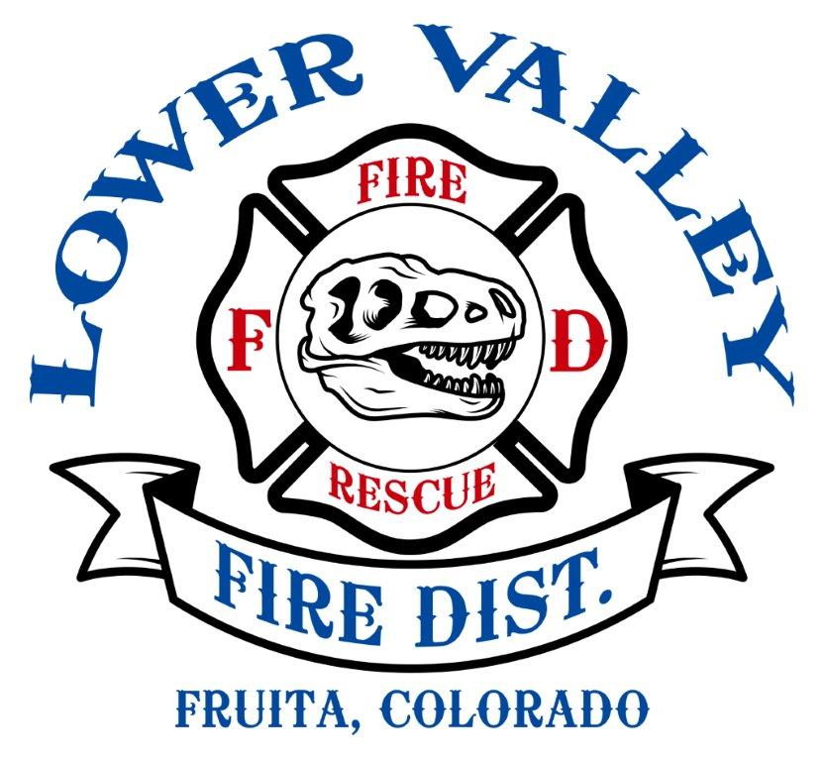

WAIVER OF LIABILITY

The Lower Valley Fire Protection District, agents, employees, volunteers, Board of Directors,
or any representative thereof are not responsible for any injury, loss or damage from any cause
whatsoever that may be suffered by participating in an agility testing as part of qualification for
a position with the District. Applicant releases the Lower Valley Fire Protection District and its
staff, agents, and/or individuals and employees for such injury, loss or damage.

No responsibility is assumed by the Lower Valley Fire Protection District, its agents, employees
for goods delivered to the site or for items left on premises before, during or after the testing.

I, as applicant agree to this Waiver of Liability and sign with that understanding.

APPLICANTS SIGNATURE

DATE

DISTRICT REPRESENTATIVE

