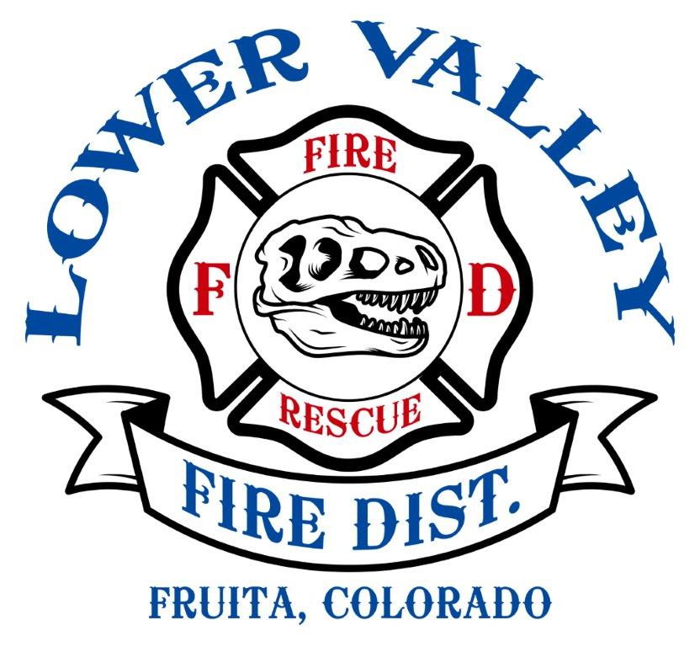

Mission Statement of the Fire Prevention Department
The mission of the Lower Valley Fire Prevention Department is to reduce loss of life, risk of fire, and property loss through education, code enforcement, and industry standard. In practice ad using modern science, we strive to educate the public of safe practices and procedures. We believe by collaborative effort, the community for which we serve can become a safe environment to live, work, and play.
The primary goal is the reduction of the serious socio-economic impacts from fire such as personal injury or death, property, and environmental damage.
Services provided by the Fire Prevention Department include: Building and Subdivision Plan Reviews, Fire Sprinkler System and Fire Alarm System Inspections/ Acceptance Testing, Fire/ Life Safety Inspections of buildings and processes. Inspections of all commercial, manufacturing, educational, and institutional properties that reside within the Fire District boundaries are conducted. The objective of these inspections is to identify and initiate correction of life/safety violations. Moreover, inspections serve as a communication link to verify contact information and familiarize fire personnel with the property in the event of fire or other emergency.
City of Fruita Ordinance 2012-05 and the Lower Valley Protection District- Resolution No. 01/19-2012 charge the Fire Prevention Department with enforcement of the 2012 International Fire Code (IFC). The Mesa County Building Department has adopted the International Building Code (IBC), which works in tandem with the IFC. A copy of the IFC may be viewed at the Lower Valley Fire Protection District Office.
LOWER VALLEY FIRE PROTECTION DISTRICT PREVENTION DEPARTMENT
168 North Mesa Fruita, CO. 81521
Phone: 970.858.3133 Ext: 3
Fax: 970.858.7620
Administrative Office Open
Monday-Friday 8am to 5 pm

LOWER VALLEY FIRE PROTECTION DISTRICT PREVENTION DEPARTMENT

Obtaining Fire Department Clearance for a Building Permit
Questions: Contact Fire Marshal

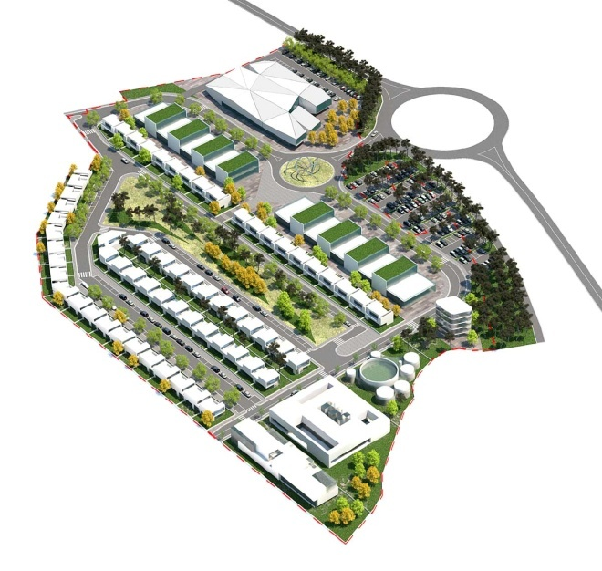

The Planning Process (Step 1)
Before you can start the Fire Department Clearance process, you must first obtain an approved Planning Clearance from either the City of Fruita Planning Department or the Mesa County Planning Department.

Planning Clearance
A planning Clearance verifies that any building issues, such as zoning, drainage, availability of utilities, etc., have been addressed before the building process takes place.

For Questions, call:
Community Development Department
(for projects in the City): 970-858-0786
OR
Mesa County Planning Department
(for projects in the County):970.244.1636

Fire Department Clearance Process for Building Permits (Step 2)
The Fire Department Clearance Process for Building Permits is a completely separate process from the Planning Process. It takes approximately 10 days for the Fire Department to review you plans. Please follow the steps below:

#1
Bring one (1) complete set of building plan to the Fire Department. The plan must be identical to the plans you submit to the Mesa County Building Department. If required by the Building Department, include an engineer or architect seal.
If you want to have a set of Fire Department approved plans, please submit two (2) complete sets for review. The Fire Department will keep a set of plans.
#2
At the front desk of the Fire Department, fill out the Plan Review Work sheet/ Building Permit Clearance form and attach it to you plans.
After the plan has been reviewed, any comments will be listed on the clearance form and you will be called to pick up the completed clearance. If there is a charge involved, you will be advised of it at the time of the call.

#3
Pick up the completed Fire Department Clearance for at the front desk.
Take one (1) copy to the Mesa County Building Department and 200 South Spruce, Grand Junction, CO.
Please note: If you submitted plans are inadequate or require change, you will be contacted to discuss what is needed. The review period does not begin until we receive acceptable plans.

For Fire Protection Systems:

If your project includes fire protection systems such as: fire sprinkler systems, hood extinguishing systems, spray booths or hazardous material storage tanks, your subcontractor for the system will submit plans and specifications under a separate clearance form.

These plans can be submitted (after) your receive you building permit.
Please be aware that we do not allow installation of these systems until we have reviewed and approved the plans.

